**PLC Timer**

The 6 relays of the PLC Timer operate differently with respect to timing capabilities. However by performing logical operations such as ANDing and ORing the Relay 6 which has no inherent timing operation associated with it, can be made to incorporate all or any of the timing operations associated with Relays 1,2,3,4,or 5.

The diagram on the next page describes the parameters that can be set to perform the various timing functions.

The description below illustrates an example of the possibilities for setting the timer.

**Set Relay 2**:

September 24 at 13 hours and 20 minutes to start

September 25 to 10 hours 15 minutes to end

Set Relay 1 to 20 minutes to start

Set Relay 1 to 30 minutes to stop.

Set Relay 1 delta 45 minutes

**Relay 6 Trigger By Logically AND Relay 1 and Relay 2 Triggers**

Result with have Relay 6 turning on at September 24, 13, hours and 20 minutes.

Relay 6 will stay on for 10 minutes, then stop.

Relay 6 will turn on again at September 24 14 hours and 5 minutes (65-60)

Relay 6 will turn off again at September 24 14 hours and 15 minutes (75-60)

This pattern will continue until September 25 at 10 hours and 15 minutes

**Start September 24, 13 hours, 20 minutes**

9/24/13/20 Relay 6 ON

9/24/13/30 Relay 6 OFF

9/24/14/05 Relay 6 ON

9/24/14/15 Relay 6 OFF

* etc

9/25/10/15 Relay 6 OFF

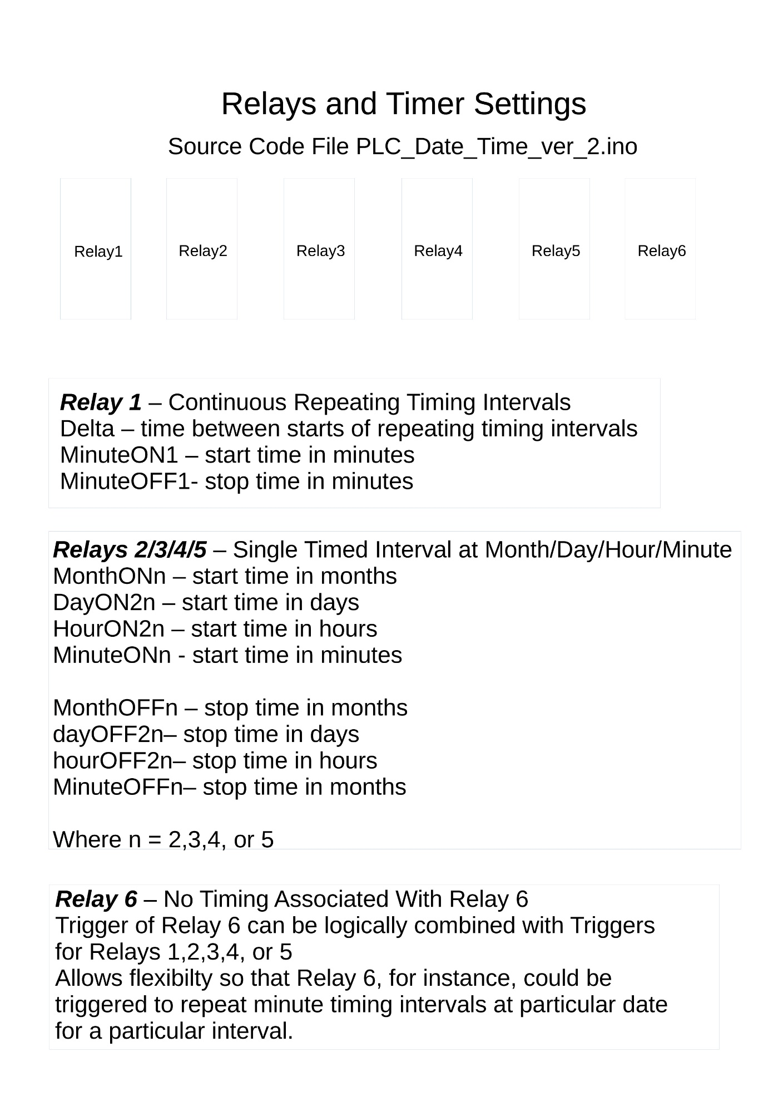

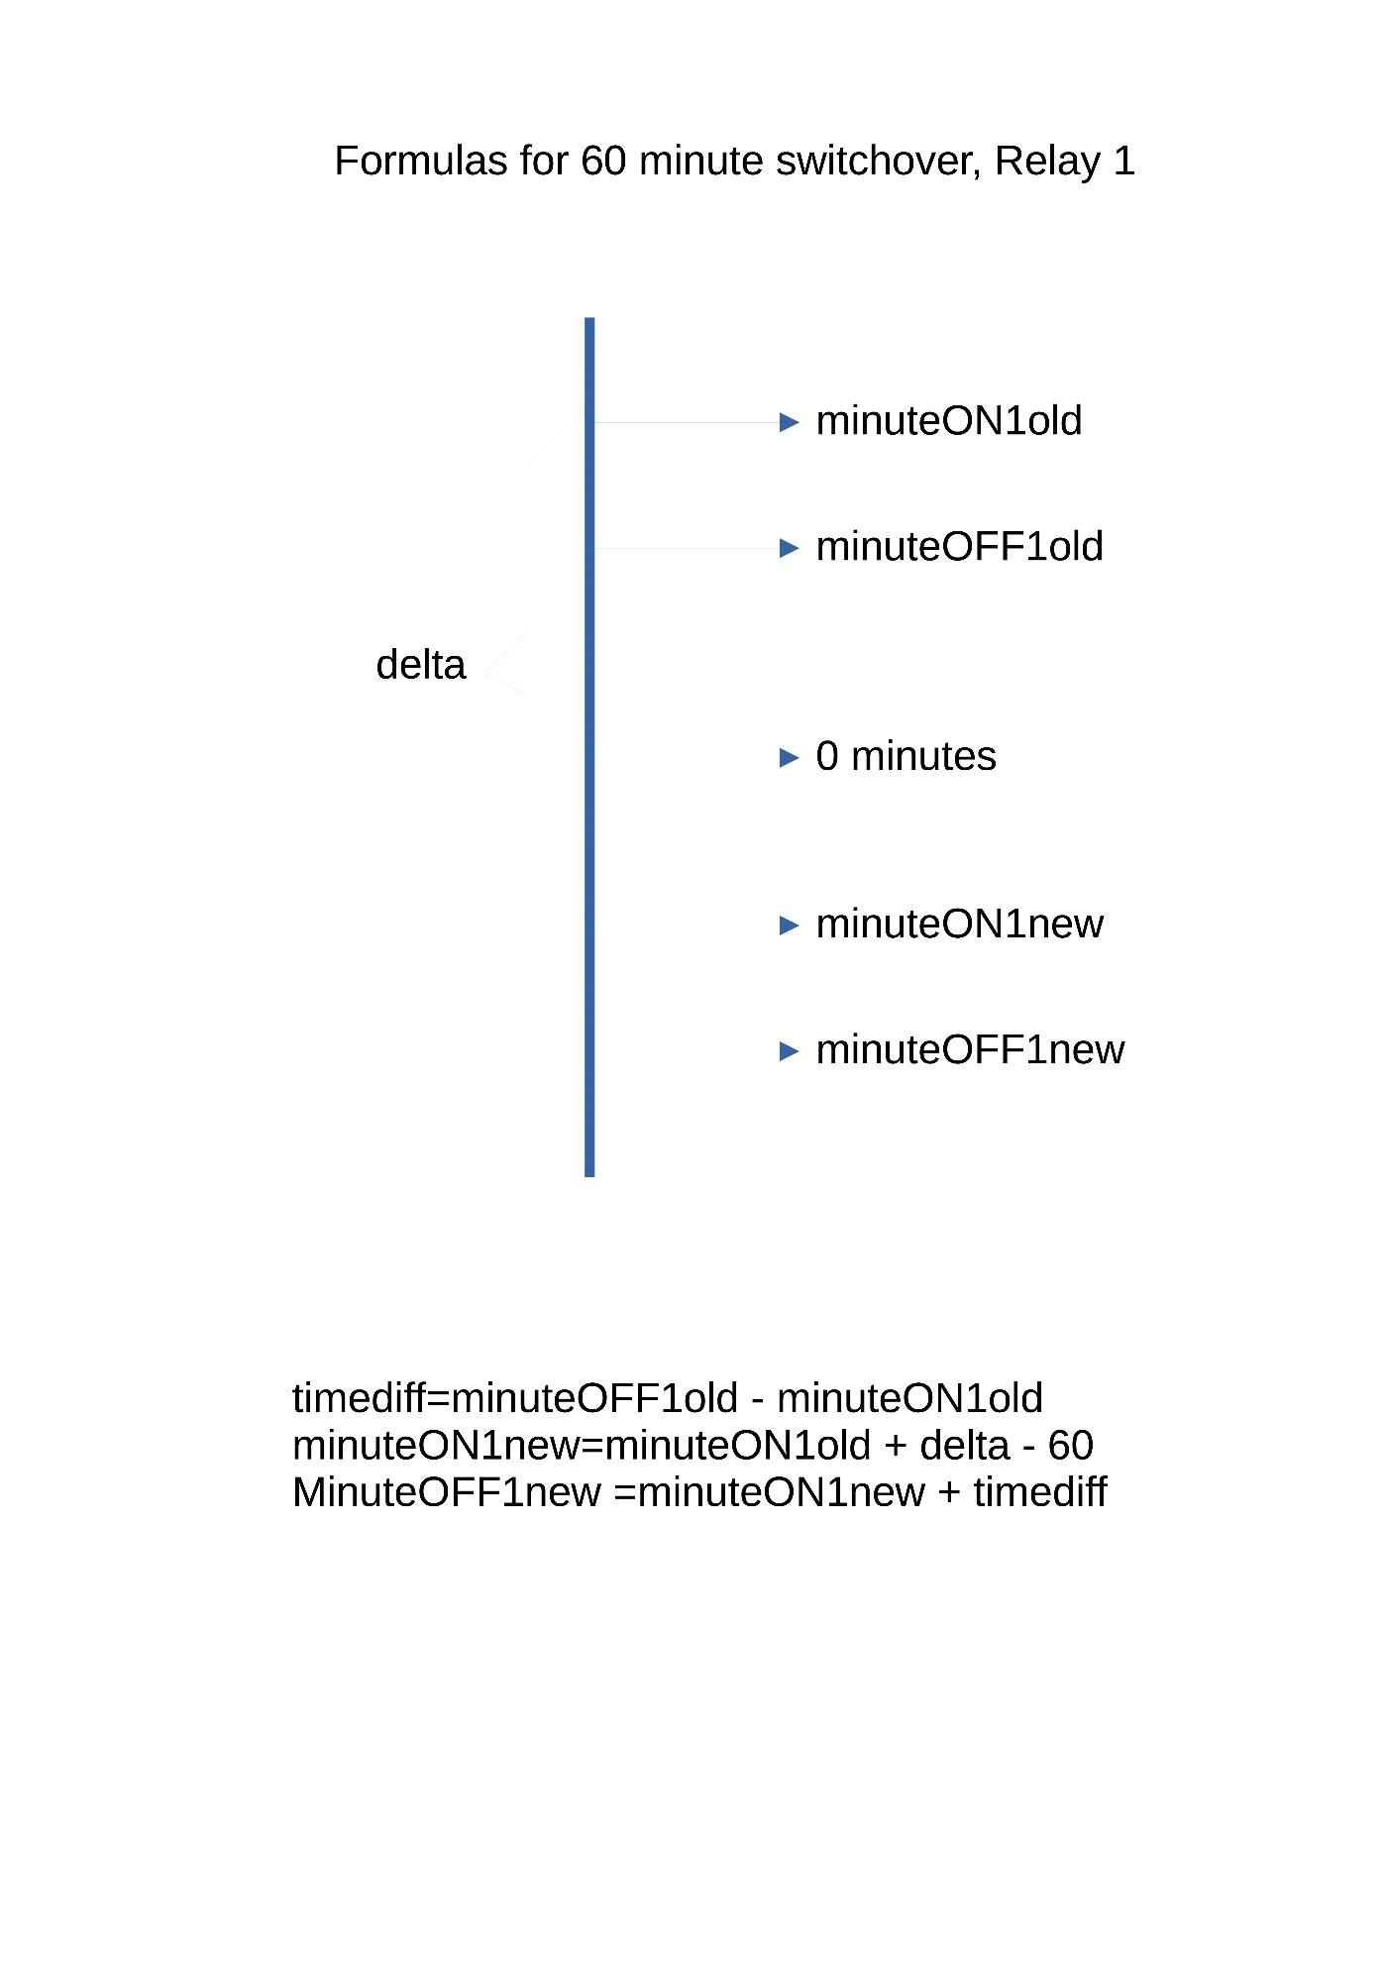

timediff